**Assignment Cyber Security Essentials**

**Question1: Find out mail servers of following domain: -**

***Ibm.com***

***Wipro.com***

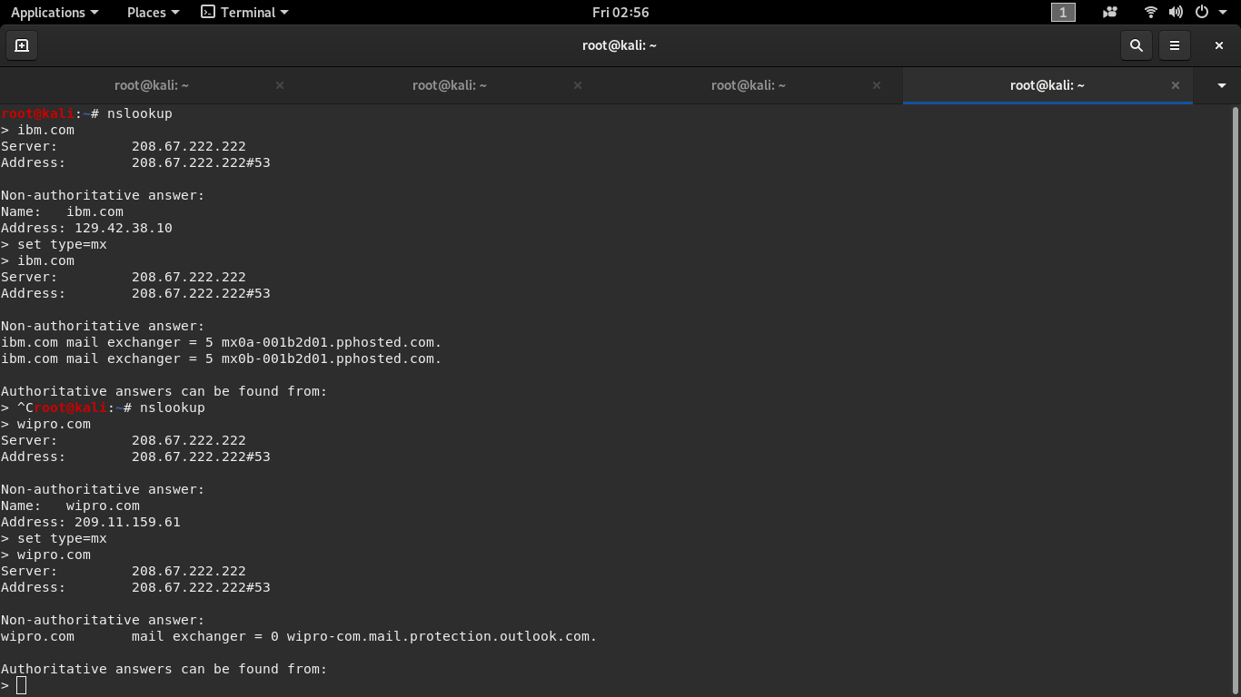

Command used for finding mail servers:

Nslookup

Set type=mx (mx stands for mail server)

**Question2: Find these locations where these email servers are hosted:**

Whoislookup to get the results

ibm.com

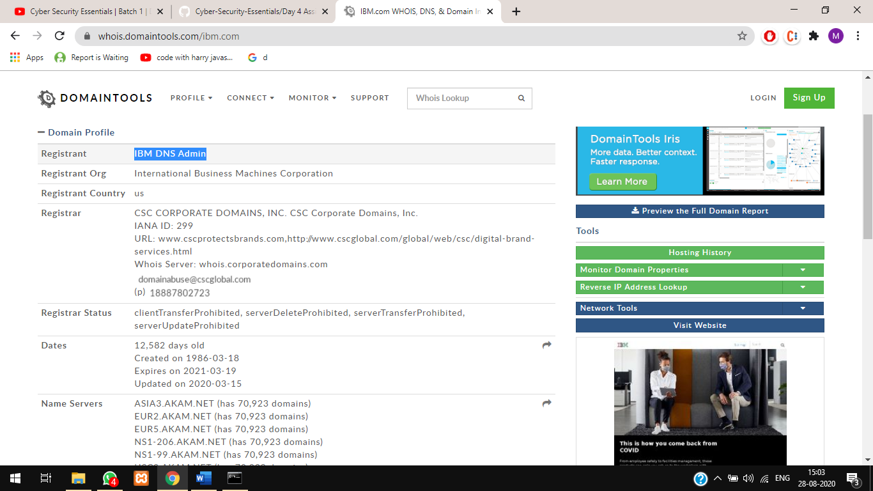

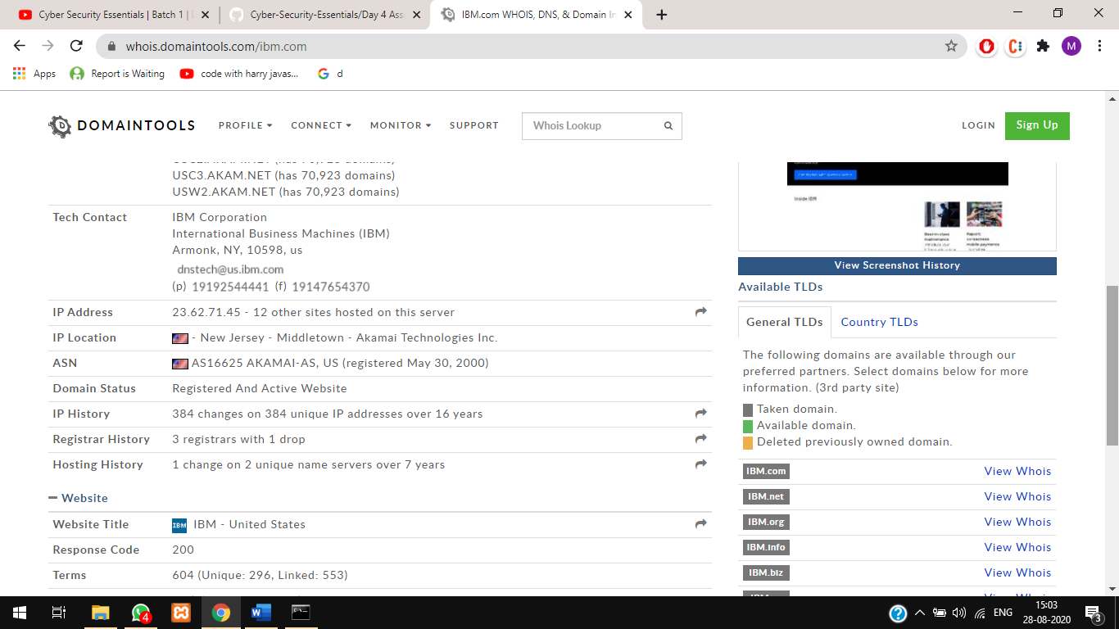

Wipro.com

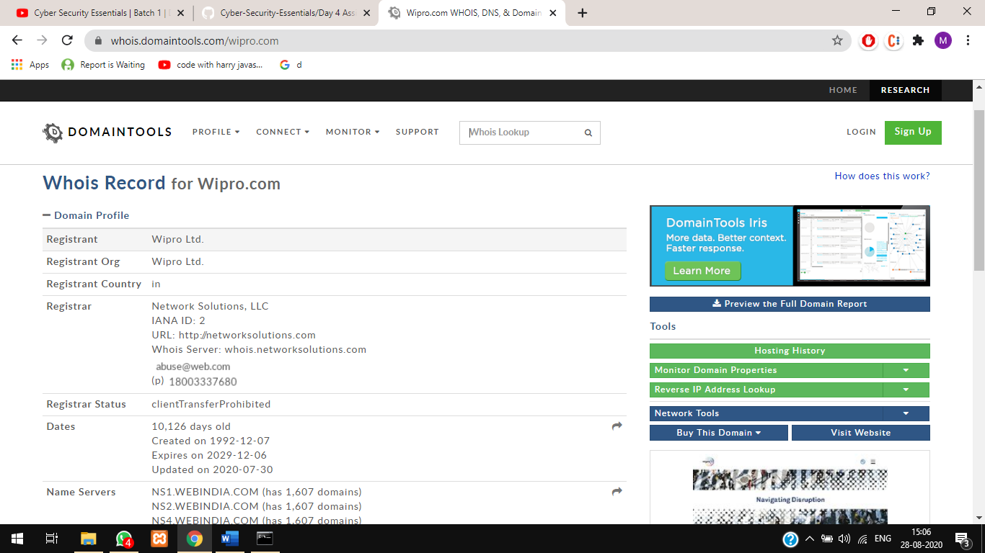

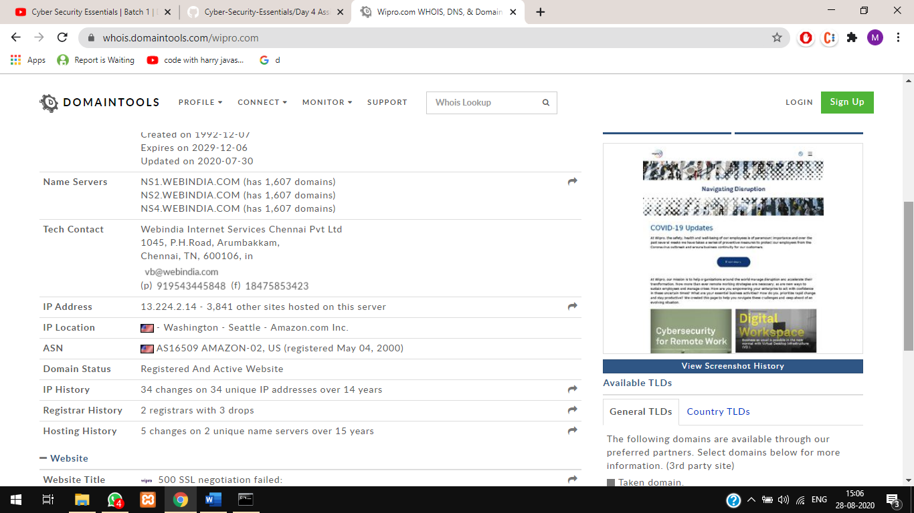

**Question3: Scan and find out port numbers open 203.163.246.23**

Nmap tool used to scan this IP

Command used:

nmap -Pn 203.163.246.26

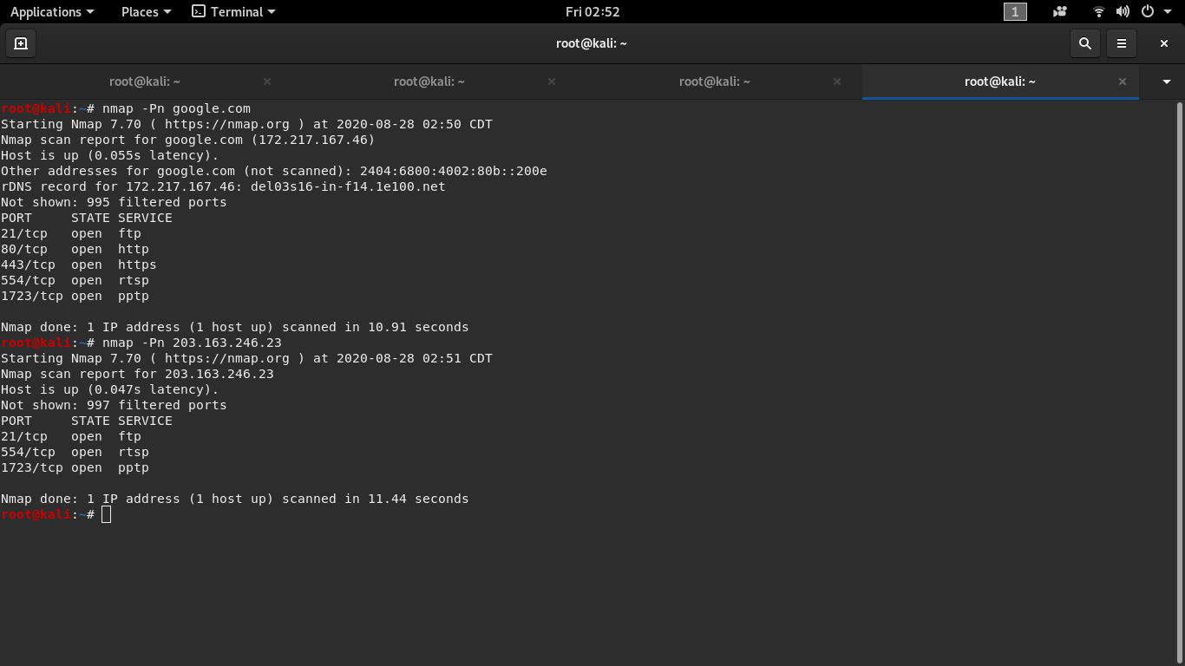

**Question4: Install Nessus in your VM and scan your laptop/desktop for CVE**